Name : Rajvardhan Reddy
Reg No : 180905093
Sec : B
Roll No : 19

OS LAB – 7 : IPC 3 - Deadlock, Locking, Synchronization

Lab Exercises :

P1) Modify the above Producer-Consumer Program so that, a producer can produce at the most 10 items more than what the consumer has consumed.

Program :

#include <stdio.h>
#include <pthread.h>
#include <semaphore.h>
#include <stdlib.h>
#include <unistd.h>

int buf[5], f, r;
sem_t mutex, full, empty;

void *produce(void *arg)
{
for (int i = 0; i < 10; i++)
{
sem_wait(&empty);
sem_wait(&mutex);

printf("Produced item is %d\n", i);

buf[(++r) % 10] = i;
sleep(1);

sem_post(&mutex);
sem_post(&full);
// printf("Full %u\n", full);
}
}

void *consume(void *arg)
{
int item;

for (int i = 0; i < 10; i++)
{
sem_wait(&full);

// printf("Full %u\n", full);

sem_wait(&mutex);
item = buf[(++f) % 10];

printf("Consumed item is %d\n", item);
sleep(1);

sem_post(&mutex);
sem_post(&empty);
}
}
int main()
{
pthread_t t1, t2;
sem_init(&mutex, 0, 1);
sem_init(&full, 0, 1);
sem_init(&empty, 0, 10);
pthread_create(&t1, NULL, produce, NULL);
pthread_create(&t2, NULL, consume, NULL);
pthread_join(t1, NULL);
pthread_join(t2, NULL);
}

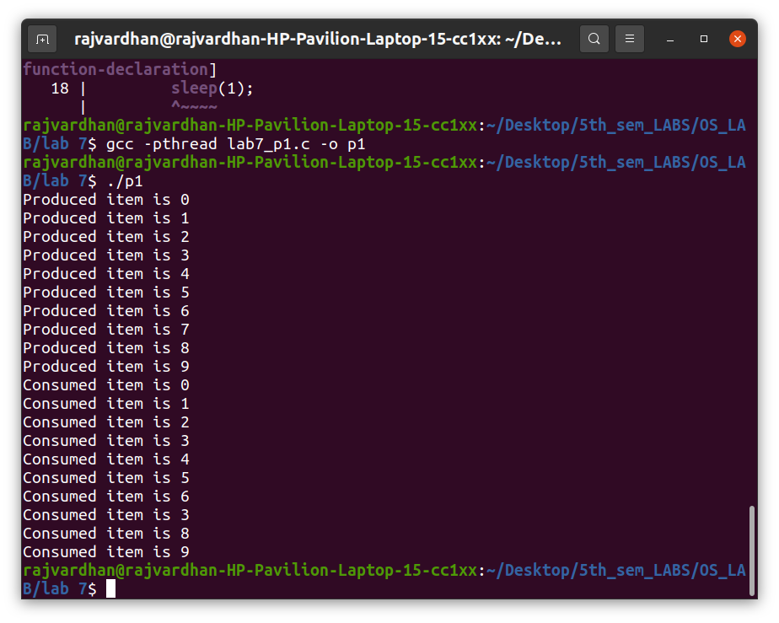
Output :

P2) Write a C program for the first readers-writers problem using semaphores.

Program :

#include <pthread.h>
#include <semaphore.h>
#include <stdio.h>
#include <stdlib.h>
#include <unistd.h>

sem_t wrt;
pthread_mutex_t mutex;
int cnt = 1;
int numreader = 0;

void *writer(void *wno)
{
sem_wait(&wrt);
cnt *= 2;
printf("Writer %d modified 'cnt' to %d\n", (*((int *)wno)), cnt);
sem_post(&wrt);
}

void *reader(void *rno)
{
pthread_mutex_lock(&mutex);
numreader++;

if (numreader == 1)
sem_wait(&wrt); // first reader will block the writer
pthread_mutex_unlock(&mutex);

// Reading Section, no locks

printf("Reader %d: read 'cnt' as %d\n", *((int *)rno), cnt);

// Reader acquire the lock before modifying numreader
pthread_mutex_lock(&mutex);
numreader--;

if (numreader == 0)
sem_post(&wrt); // If this is the last reader, it will wake up the writer.

pthread_mutex_unlock(&mutex);
}

int main()
{
pthread_t read[10], write[5];
pthread_mutex_init(&mutex, NULL);

sem_init(&wrt, 0, 1);

int a[10] = {1, 2, 3, 4, 5, 6, 7, 8, 9, 10}; //used for numbering the producer and consumer

for (int i = 0; i < 10; i++)
pthread_create(&read[i], NULL, reader, &a[i]);
for (int i = 0; i < 5; i++)
pthread_create(&write[i], NULL, writer, &a[i]);
for (int i = 0; i < 10; i++)
pthread_join(read[i], NULL);
for (int i = 0; i < 5; i++)
pthread_join(write[i], NULL);

pthread_mutex_destroy(&mutex);
sem_destroy(&wrt);
return 0;
}

Output :

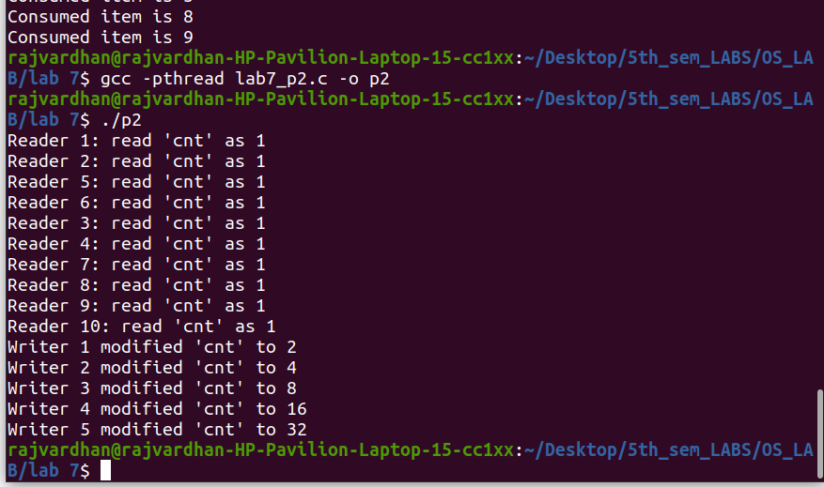

P3) Write a Code to access a shared resource which causes deadlock using
improper use of semaphore.

Program :

#include <stdio.h>
#include <unistd.h>
#include <pthread.h>
#include <sys/sem.h>

#define PERMS 0660

int semId;
int initSem(int semId, int semNum, int initValue)
{
return semctl(semId, semNum, SETVAL, initValue);
}

int P(int semId, int semNum)
{
struct sembuf operationList[1];
operationList[0].sem_num = semNum;
operationList[0].sem_op = -1;
operationList[0].sem_flg = 0;
return semop(semId, operationList, 1);
}

int V(int semId, int semNum)
{
struct sembuf operationList[1];
operationList[0].sem_num = semNum;
operationList[0].sem_op = 1;
operationList[0].sem_flg = 0;
return semop(semId, operationList, 1);
}

void* funcA(void* nothing)
{
printf("Thread A try to lock 0...\n");
P(semId, 0);
printf("Thread A locked 0.\n");
usleep(50*1000);
printf("Thread A try to lock 1...\n");
P(semId, 1);
printf("Thread A locked 1.\n");
V(semId, 0);
V(semId, 1);
return NULL;
}

void* funcB(void* nothing)
{
printf("Thread B try to lock 1...\n");
P(semId, 1);
printf("Thread B locked 1.\n");
usleep(5*1000);
printf("Thread B try to lock 0...\n");
P(semId, 0);
printf("Thread B locked 0.\n");
V(semId, 0);
V(semId, 1);
return NULL;
}

int main(int argc, char* argv[])
{
int i;
semId = semget(ftok(argv[0], 'A'), 2, IPC_CREAT | PERMS);
initSem(semId, 0, 1);
initSem(semId, 1, 1);
pthread_t thread[2];
pthread_create(&thread[0], NULL, funcA, NULL);
pthread_create(&thread[1], NULL, funcB, NULL);

for (i = 0 ; i < 2 ; i++)
{
pthread_join(thread[i], NULL);
}

printf("This is not printed in case of deadlock\n");
semctl(semId, 0, IPC_RMID, 0);
semctl(semId, 1, IPC_RMID, 0);
return 0;
}

Output :

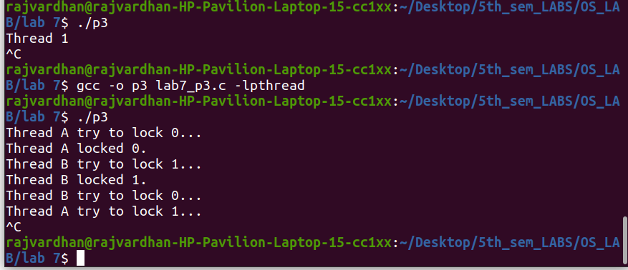
P4) Write a program using semaphore to demonstrate the working of sleeping barber problem.

Program :

#include <stdio.h>
#include <pthread.h>
#include <semaphore.h>
#include <stdlib.h>
#include <unistd.h>

sem_t customer, barber;
pthread_mutex_t seat;
int free1 = 10;
void *br(void *args)
{
while (1)
{
sem_wait(&customer);
pthread_mutex_lock(&seat);

if (free1 < 10)
free1++;
sleep(2);

printf("Cutting completed : free seats : %d\n", free1);
sem_post(&barber);

pthread_mutex_unlock(&seat);
}
}

void *cr(void *args)
{
while (1)
{
pthread_mutex_lock(&seat);

if (free1 > 0)
{
free1--;

printf("Customer waiting : free seats : %d\n", free1);
sem_post(&customer);
pthread_mutex_unlock(&seat);
sem_wait(&barber);
}
else
pthread_mutex_unlock(&seat);
}
}

int main()
{
pthread_t threads[2];
sem_init(&barber, 0, 1);
sem_init(&customer, 0, 1);
pthread_mutex_init(&seat, 0);
pthread_create(&threads[0], NULL, br, NULL);
pthread_create(&threads[1], NULL, cr, NULL);
pthread_join(threads[0], NULL);
pthread_join(threads[1], NULL);
sem_destroy(&barber);
sem_destroy(&customer);
pthread_mutex_destroy(&seat);
}

Output :

